**ASSIGNMENT -1(DSA 0105 OOPS WITH C++)**

NAME: AADITYA PARTIBAN

REG.NO: 192211037

QUESTION 9  
(A)- OUTPUT WILL BE “less than 10”

(B)- OUTPUT WILL BE “greater than 5”

(C)- OUTPUT WILL BE “less than 10”

(D)-OUTPUT WILL BE “not interesting”

QUESTION 10

#include <iostream>

using namespace std;

int main() {

int n;

do {

cout << "Enter a non-negative integer: ";

cin >> n;

if (n < 0) {

cout << "The integer you entered is negative." << endl;

}

} while (n < 0);

    return 0;

}

QUESTION 7

(a)-output of the program as it is written will be 0.

(b)- Corrected program will be:

int n=10;

while(n>0){

n/=2;

}

Cout<<n*n<<endl;

QUESTION 1

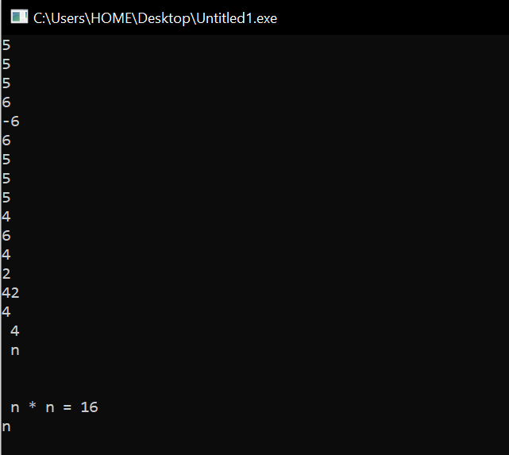

QUESTION 2

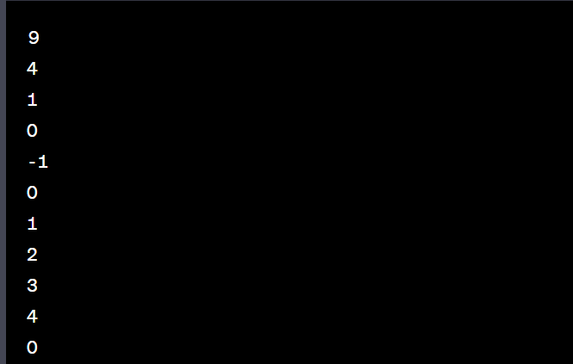

QUESTION 8

float income;

cout << "Enter your monthly income: ";

cin >> income;

if (income < 0.0)

cout << "You are going farther into debt every month." << endl;

else if (income < 1200.00)

cout << "You are living below the poverty line." << endl;

else if (income < 2500.00)

cout << "You are living in moderate comfort." << endl;

else

cout << "You are well off." << endl;

QUESTION 5

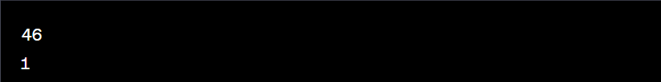

QUESTION 4

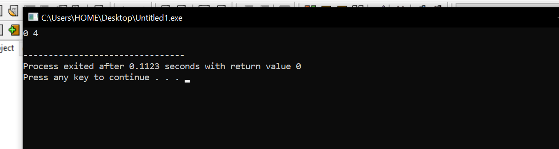

QUESTION 3

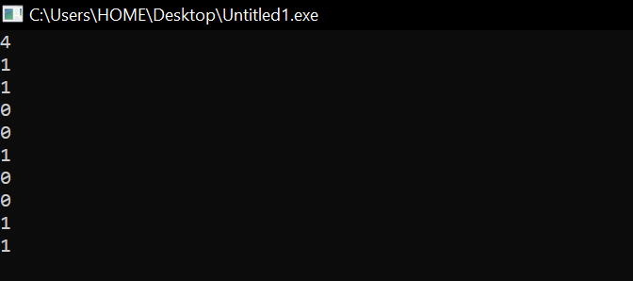

QUESTION 6

